Task 1 – Read it aloud to each other. Remember: pronounce every syllable!

Whan that Aprill with his shoures soote
When April with its sweet-smelling showers
2 The droghte of March hath perced to the roote,
Has pierced the drought of March to the root,
3 And bathed every veyne in swich licour
And bathed every vein (of the plants) in such liquid
4 Of which vertu engendred is the flour;
By the power of which the flower is created;
5 Whan Zephirus eek with his sweete breeth
When the West Wind also with its sweet breath,
6 Inspired hath in every holt and heeth
In every holt and heath, has breathed life into
7 The tendre croppes, and the yonge sonne
The tender crops, and the young sun
8 Hath in the Ram his half cours yronne,
Has run its half course in Aries,
9 And smale foweles maken melodye,
And small fowls make melody,
10 That slepen al the nyght with open ye
Those that sleep all the night with open eyes
11 (So priketh hem Nature in hir corages),
(So Nature incites them in their hearts),
12 Thanne longen folk to goon on pilgrimages,
Then folk long to go on pilgrimages,
13 And palmeres for to seken straunge strondes,
And professional pilgrims (long) to seek foreign shores,
14 To ferne halwes, kowthe in sondry londes;
To (go to) distant shrines, known in various lands;
15 And specially from every shires ende
And specially from every shire's end
16 Of Engelond to Caunterbury they wende,
Of England to Canterbury they travel,
17 The hooly blisful martir for to seke,
To seek the holy blessed martyr,
18 That hem hath holpen whan that they were seeke.
Who helped them when they were sick.
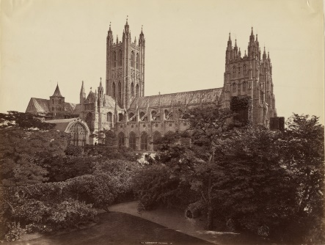
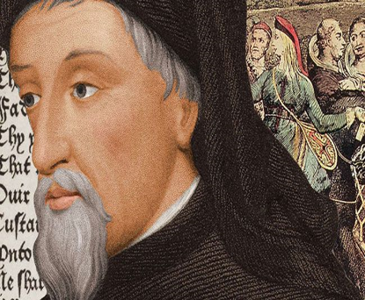

Task 2
Follow this extract as I read. The image below comes from one of the few surviving contemporary manuscripts of the Canterbury Tales, dating from just after 1400. Chaucer has just described the Knight and now turns to his son…

With hym ther was his sone, a yong SQUIER,
A lovyere and a lusty bacheler;
With lokkes crulle, as they were leyd in presse.
Of twenty yeer of age he was, I gesse.
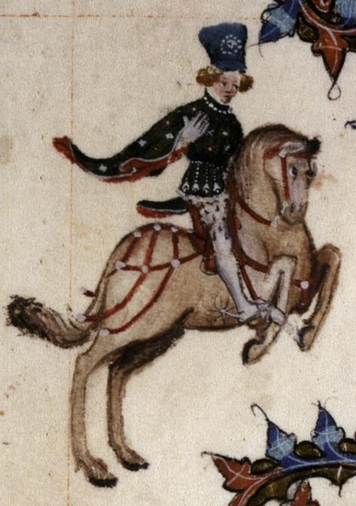
Of his stature he was of evene lengthe,
And wonderly delyvere, and of greet strengthe.
And he hadde been somtyme in chyvachie
In Flaundres, in Artoys, and Pycardie,
And born hym weel, as of so litel space,
In hope to stonden in his lady grace.
Embrouded was he, as it were a meede,
Al ful of fresshe floures, whyte and reede;
Syngynge he was, or floytynge, al the day,
He was as fressh as is the monthe of May.
Short was his gowne, with sleves longe and wyde.
Wel koude he sitte on hors, and faire ryde.
He koude songes make, and wel endite,
Juste, and eek daunce, and weel purtreye and write.
So hoote he lovede, that by nyghtertale
He slepte namoore than dooth a nyghtyngale.
Curteis he was, lowely, and servysable,
And carf biforn his fader at the table.

Task 3
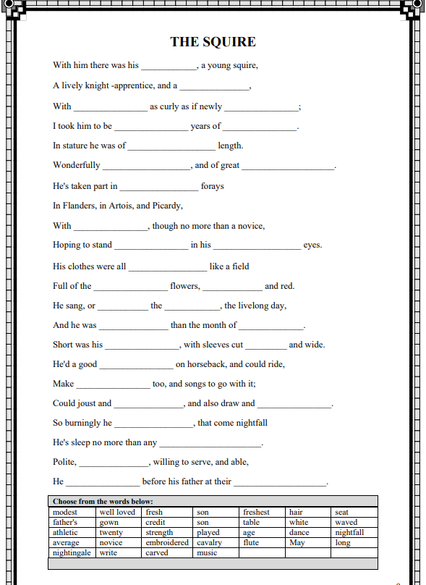
In groups (or individually), re-read the Squire’s portrait and use the table below to fill in the gaps here… and you’re well on way to reading Middle English! You can use the manuscript illu
Task 4
(A)
Write your own portrait of someone you know well in eth style of the Squire’s portrait.
We have looked at how Chaucer has done it – he was keen to observe the 'estaat' (status/job), the 'array (clothing and physical appearance) and the 'condicioun', or someone's character and personality. In other words, what does their behaviour and looks suggest about them as a person? Do they say one thing, and do another? Whatever you decide, make your description real and make it human. Write about what you know.
Guidelines to follow
Begin your pen portrait 'A [blank] there was…’ to give it an instant Chaucerian feel. In the blank you can insert schoolgirl, schoolboy, runner, cellist, artist, teacher, father, whatever you decide!
Looking for a challenge?
If you want an extra challenge write your description in poetry using Chaucer’s distinctive meter and rhyme scheme – that means using rhyming couplets and making sure each line has five stresses to make it an IAMBIC PENTAMETER line e.g.
With lokkes crulle, as they were leyd in presse.
Of twenty yeer of age he was, I gesse.
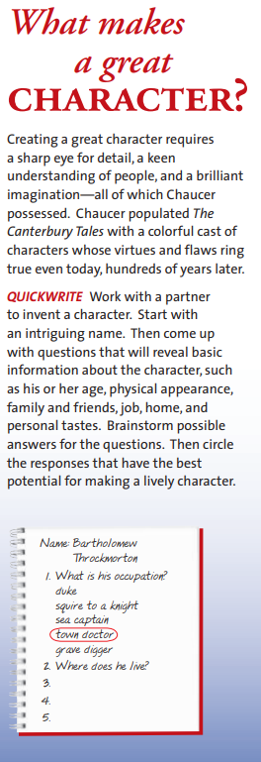
OR

(B)

OR

(C) Describe your return to a place struck down by the plague. You can base your writing in any time period you like.

OR

(D) ‘What have we, as a society, learnt in the last year, and what measures should we keep in a post-Covid world?’
- Write a piece that argues that the corona virus, despite all its damage, has made our world a better place.

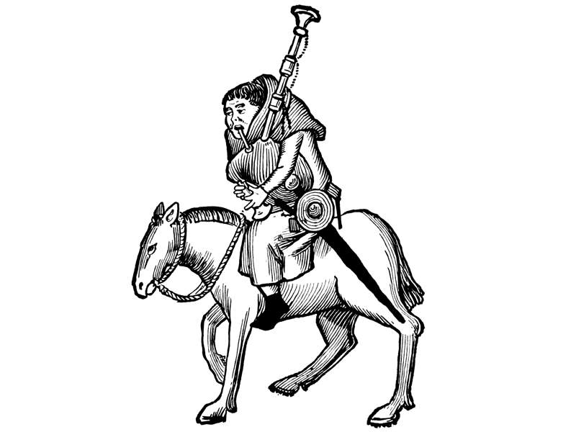
Find out more from the British Library at https://www.bl.uk/people/geoffrey-chaucer

